

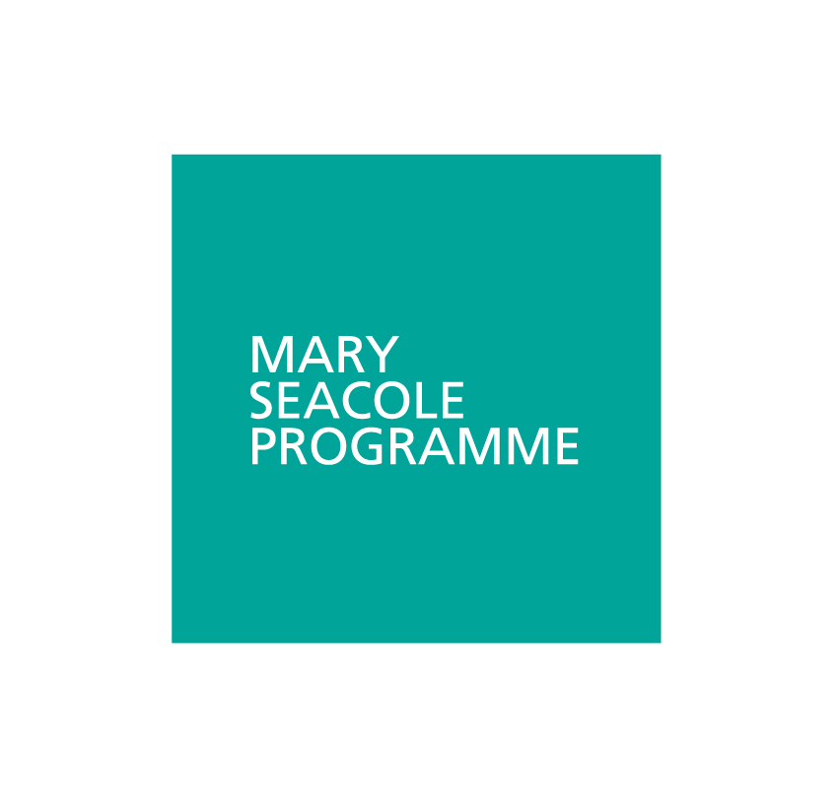

Mary Seacole Programme

**Applicant guide**

**2019-20**



www.leadershipacademy.nhs.uk

**Contents**

|  |  |
| --- | --- |
| **Applicant suitability** | **3** |
| **Programme summary** | **4** |
| **Mary Seacole Programme overview** | **5** |
| **Learning** | **6 - 7** |
| **Units of study** | **8 - 9** |
| **Guidance for completing your application form** | **10 - 12** |
| **Personal statement** | **13 - 14** |
| **Next steps and contact us** | **15** |
|  |  |

**Applicant suitability**

The Mary Seacole programme is for **first time leaders in healthcare**, or those

**aspiring to their first formal leadership role**. It’s for you if you’re:

* Looking to move into your first leadership role
* In a ‘formal’ position of leadership with responsibilities for people and services
* Able to relate what you learn to your workplace

**The programme is six months long with 100 hours of online study, plus three face-to-face behavioural workshops delivered locally.**

Learning is accessed through:

* The Academy’s virtual campus, which includes films, interactive content, discussion forums, and online resources
* Three one day face-to-face skills workshops working with expert facilitators delivered around the country

You must be able to attend all three face-to-face workshops, as attendance at these is mandatory. **We don’t offer deferrals under any circumstance** and we can’t guarantee a place at an alternative workshop if you’re unable to attend one of the days listed.

Applications will close five weeks prior to the start date of each individual cohort, unless otherwise stated.

**English language requirements**

We welcome applications from candidates with a range of overseas qualifications. In order to undertake the programme, you’ll need to demonstrate that you have a good level of written and spoken English with an Undergraduate or Master’s degree from an English-speaking institution, IELTS/TOEFL/PTE or alternative qualifications.

**Programme summary**

|  |  |
| --- | --- |
| Programme title | Mary Seacole |
| Award | **NHS Leadership Academy Award in Healthcare Leadership** |
| Length of programme | **6 months** |
| Time commitment | **At least 4 hours a week** |
| Out of office days | **3x one-day workshops** |
| Modes of study | **Online learning and face-to-face workshops** |
| Programme dates | **Available on** [**our website**](http://www.leadershipacademy.nhs.uk/programmes/mary-seacole-programme/dates/) |

**Fees and funding**

The full cost of the programme is detailed below and varies depending on your organisation and situation. The fees detailed below are fully inclusive of three face-to-face workshops including lunch and refreshments, and access to our state of the art online Virtual Campus. Accommodation and travel aren’t included.

|  |  |
| --- | --- |
| Full cost | £1,700 |
| NHS subsidised cost | **£995 (If providing NHS Funded care)** |

Fees are payable in full prior to the start of the programme via invoice. You’ll

need to provide a purchase order number.

**Self-funding**

Participants are able to self-fund a place on the programme. Please contact us

using the details on page 15 if you wish to discuss further.

**Mary Seacole Programme**

**Overview**

As people take on leadership responsibilities, their relationship with their organisation and the people around them shifts. Expectations change, accountabilities increase, and scrutiny grows. This programme explores key themes with which new leaders need to engage, and how they’ll understand and apply them to their own situation. The idea of ‘something has changed – and what does this mean?’ runs through the programme. A leadership role is a significant change of role, and the programme will actively encourage you to consider what that change means for you, and how you might need to behave in the workplace to be a success in your role.

**Profile**

Created by the NHS Leadership Academy in conjunction with internationally renowned business and academic experts Korn Ferry Hay Group, the programme provides the opportunity for you to develop your leadership and management skills leading to a NHS Leadership Academy Award in Healthcare Leadership. And while you’re helping improve the NHS for our patients’ benefit, the Mary Seacole Programme will do the same for your career prospects by helping you to:

* Learn from innovative, world-class healthcare experts, preparing you for the demands of first-time leadership
* Improve your personal impact to help drive progress with your team and organisation to build a culture of patient-focused care
* Build a powerful regional and national support network of like-minded influential leaders

**Learning**

The Mary Seacole Programme will prepare you for the demands of leadership in the healthcare system today – and into the future. It will give you the theoretical knowledge and practical understanding needed to deliver inspiring leadership. The learning methods are a cutting-edge blend to keep you inspired and motivated via a flexible state-of-the-art virtual campus and face-to-face development. And to keep it all fresh and current, you’ve got the latest thinking from world-class experts. You’ll emerge from the programme with the professional skills to thrive in a leadership role and ready to play your part in building a more compassionate NHS.

**Learning methods**

There are three core learning methods on this programme:

* Work-based learning
* Face-to-face learning at workshops
* Online via the virtual campus

**Work-based Learning**

Work-based Learning (WBL) is an important part of how the learning methods are applied in practice. WBL takes as its focus the work you’re already doing and uses this as the basis for your learning. Much of your online learning will relate to your work place. It focuses your attention on what’s practical and helps to lighten the study workload, as some of the learning is within your day-to-day job.

**Face-to-face learning: workshops**

There are three workshops during the course of the programme, the dates of which you can find on our website. The focus of these workshops will be on your personal and behavioural development in context; they take full advantage of face-to-face group work, experiential and simulation learning activities, and social networking opportunities.

Attendance at these workshops is mandatory. Please make sure you can attend all three workshops - we can’t guarantee an alternative date if you’re unable to attend one of the dates.

**Online learning (Virtual Campus)**

The NHS Leadership Academy’s Virtual Campus has been designed to feel like an inviting space; delivering what you need in an interactive learning environment.

It’s where you’ll find all the resources you’ll need for your studies. It provides a range of different learning formats such as e-learning nuggets, simulation events, videos, surveys, electronic journals, books, discussion forums, and more.

You must make regular contributions to the discussion forums and facilitator

provocations as part of your assessment.

**Learning support**

Within your application, you’ll be given the opportunity to tell us about any disabilities and/or learning needs you may have. This information will be used to help us establish how best we can support you should you be offered a place on the programme. It won’t influence whether your application is successful.

**Units of study**

The programme consists of a six-month learning journey; comprising 12 study units, and explores the knowledge, skills and behaviours that are important for leading others when building a culture of patient-centred care within the healthcare system. You’ll be working for around four hours a week, in which you’ll explore themes that support your self-development, teams and organisations to:

* Ensure patients have good quality and safe experiences
* Understand how you make a difference to an improved patient experience
* Enable others to give their best to improve the patient experience
* Embed behaviours that improve the patient experience
* Inspire person-centred coordinated care
* Make decisions based upon the best available evidence to improve the patient experience

**Unit 1: Launch – why does leadership matter?**

This unit covers how the programme works, stages of personal development, and focuses on your own personal values.

**Unit 2: Patients, care, and context**

This unit is an integral part of the programme with much of this running across all units, focusing on patient experience and their stories, patient leadership, patient safety and the human factors.

**Unit 3: Myself and my role**

This unit looks at the definitions of management and leadership and ways of thinking about leadership.

**Unit 4: Teams and success**

This unit focuses on team dynamics, leadership responsibility, and inclusion.

**Unit 5: Relationships, influence and your system**

This unit reflects on you as part of the system; it covers relationship mapping,

influencing others, negotiation, and looking at the broader care system.

**Unit 6: Impact of organisational culture**

In this unit, you’ll focus on organisation culture, what do we mean by this, how it is developed, and your role as a leader.

**Unit 7: Focus on performance**

This unit looks at what do we mean by performance, different views on performance, and creating the climate for performance as well as performance management.

**Unit 8: Leading for improvement**

This unit looks at improvement, the model for improvement, and how to make

improvements.

**Unit 9: Recruitment and selection**

**Unit 10: Appraisal**

**Unit 11: Finance fundamentals**

**Unit 12: HR fundamentals**

The four additional management units cover:

* Recruitment and selection
* Appraisal
* Financial fundamentals
* HR fundamentals, focusing on skills, behaviour, and knowledge

These units are mandatory, but can be accessed and completed at any time during the programme, which may be particularly useful if you need to apply the learning within your role at a given point in time (e.g. appraisal season).

**Assessment**

You’ll be assessed on four activities:

* Mandatory attendance at all three face-to-face workshops
* Completion of all online content on the Virtual Campus
* Regular contributions to online discussion forums and facilitator provocations
* Submission of a 2,000-word reflective essay at the end of the programme

**Guidance for completing your application form**

All applications must be completed online via <https://nhsx.uk/> during the [live application period](http://www.leadershipacademy.nhs.uk/programmes/mary-seacole-programme/dates/). If you experience any technical problems during your application, please email [support@leadershipacademy.nhs.uk](mailto:support@leadershipacademy.nhs.uk).

**New user**

If you haven’t used NHSx before, you’ll need to register by clicking ‘Register’ at the top of the screen, highlighted below:

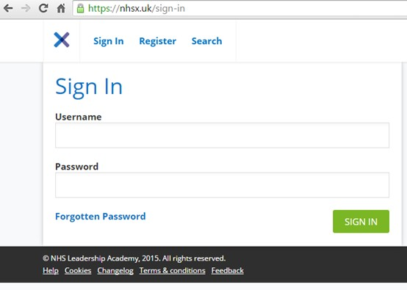

On the ‘Register with NHSx’ page, fill in your first name, last name, email address and choose a secure password, then click ‘create account’ in the green box.

You’ll then be able to log in using the details given during registration.

**Existing user**

If you’ve registered with NHSx before, you can log straight in from the home page shown above.

If you’ve forgotten your password click ‘Forgotten Password’ to recover it.

**Completing the application form**

Once you’ve logged in, you’ll be taken to the ‘Dashboard’. If you have applied for or completed any programmes before, this will be broken down into ‘Programmes I’m on’ and ‘Available Programmes’.

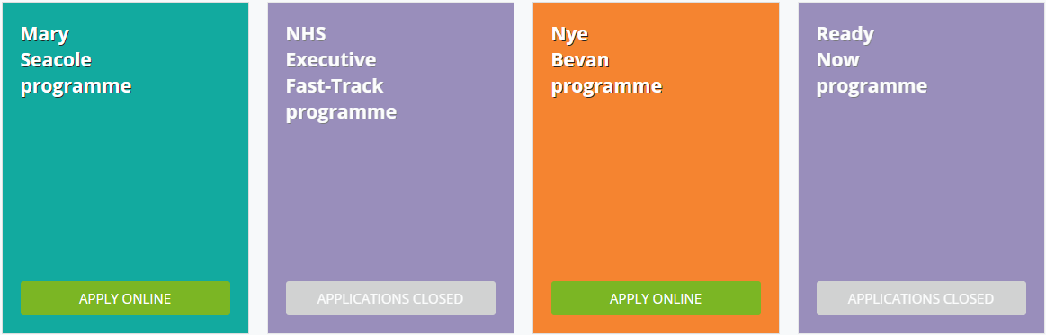To apply for the Mary Seacole programme, scroll down to ‘Available Programmes’ and click the green ‘Apply Online’ button as shown below.

You can then complete the application form. You can save your form at any point and come back to it later by clicking ‘Save for Later’ in the green box at the bottom of the application form.

Please ensure that you complete all fields on the application form, and that all entered information is correct and accurate as you may not be able to edit this once your application has been submitted.

Once you’ve completed all of the necessary information, including your personal statement, you’ll need to upload the signed **Terms and Conditions**.

To do this, click ‘choose file’ to open your file explorer and choose the correct document. This should be in Word or PDF format. Click on the selected document, then click ‘open’. The document has been uploaded when the file 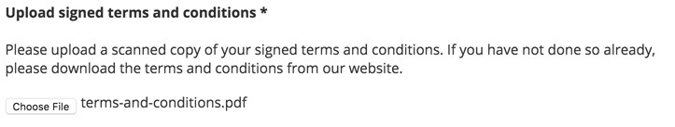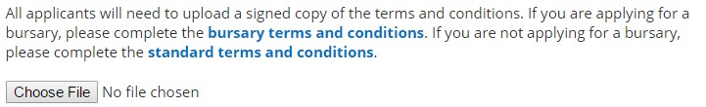name appears next to the ‘choose file’ button as below.

You can only upload one document using this function. Clicking ‘choose file’ again will overwrite any previously uploaded document.

Once you have completed your form, and uploaded all of the necessary documents, click:



**Personal statement**

Your personal statement is an important part of your application and should explain why you’re interested in studying on this programme, your relevant experience, and provide a clear argument for why you should have a place. It should be **500 words ± 10%**. To support us in reviewing your application for suitability, we’d strongly encourage you to make full use of the word count.

This programme leads to a NHS Leadership Academy Award in Healthcare Leadership. Please give consideration to your suitability and capability to commit to the programme.

Your statement should address the following questions, which will be used to score your application from 1 (very poor) to 5 (excellent):

1. Why should I have a place on this programme? And why now?
2. What is my relevant professional and leadership experience?
3. Your current role and the people you lead
4. How you plan to meet the requirements for four hours of study per week
5. What support will your line manager/organisation provide for you while you’re on the programme?

**Guidelines for writing a personal statement**

Your personal statement should be personal and unique to this programme. Once you’ve written your statement, ask yourself “could this statement apply equally to my friend or neighbour?”

Don’t underestimate how difficult it can be to write a good personal statement that will do you justice. You should make sure you have ample time to write it.

Always use good vocabulary and grammar. Use well-written sentences that flow easily to make your statement fresh and dynamic. Avoid using overly long sentences.

Keep the tone of your statement positive and enthusiastic. You need to demonstrate that you’re able to make the points required in a concise manner, and make sure you adhere to the word limit.

Write a draft and keep checking it, shortening it if needed and rewriting it until it feels right. You could perhaps ask someone to read it for you and suggest any areas for improvement.

**Structure**

Your statement should be structured with a clear beginning, middle and end. You should try to grab the reader’s attention in your introduction, and hold it so they remain interested until the end.

In the main body of the statement, concentrate on relating your skills, knowledge and experience to the questions on page 13, making sure you answer each one.

Conclude by summarising your statement for the reader. Your conclusion should not contain any new information.

**Next steps**

Use this checklist to ensure that you’ve taken all the necessary steps to complete and submit your application.

* Started your online application form
* Filled in all of your personal details accurately
* Entered your personal statement of no more than 500 words ± 10%
* Fully understood the time commitment needed to be successful
* Submitted your application form before the deadline

You’ll receive a courtesy notification email acknowledging receipt of your application within one week of submission.

You’ll be notified of your application outcome four weeks prior to the cohort start date via the email address provided in your application.

If any of your contact details change, please notify the Academy as soon as possible.

**Contact us**

If you’d like to talk to us, we’d be more than happy to help you. Please feel free to contact us using the details below:

**Phone**

**0113 322 5699**

**Email**

**SeacoleProgramme.nla@hee.nhs.uk**

**Twitter**

**@NHSLeadership**

**Website**

**www.leadershipacademy.nhs.uk**