National drivers for

Talent Management

www.leadershipacademy.nhs.uk

Developing People: Improving Care

A national framework for action on improvement and leadership development in NHS funded services was launched in December 2016. It was refreshed in February 2019.

What is this framework: It provides guidance for local, regional and national action on developing NHS-funded staff Its sponsors are the main national organisations with NHS responsibilities. The framework applies to everyone in NHS-funded roles in all professions and skill areas, clinical and otherwise Future updates are expected to cover people in social care as well.
What is the framework’s purpose? To equip and encourage people in NHS-funded roles to deliver continuous improvement in local health and care systems and gain pride and joy from their work. To that end, the framework aims to guide team leaders at every level of the NHS to develop a critical set of improvement and leadership capabilities among their staff and themselves.

Who is this document for? This document is directed primarily at the senior management teams of all organisations and partnerships responsible for NHS-funded activity. The idea is to release regular updates, improved by feedback from teams using the framework.

Why? Evidence and experience from high performing health and care systems shows that having these capabilities enables teams to continuously improve population health, patient care, and value for money Developing these capabilities and giving people the time and support required to see them bear fruit is a reliable strategy for closing the gaps identified in the NHS Long Term Plan.

The framework identifies critical capabilities to develop as being:

- System leadership skills  - Improvement skills  - Compassionate, inclusive leadership skills  - Talent management | 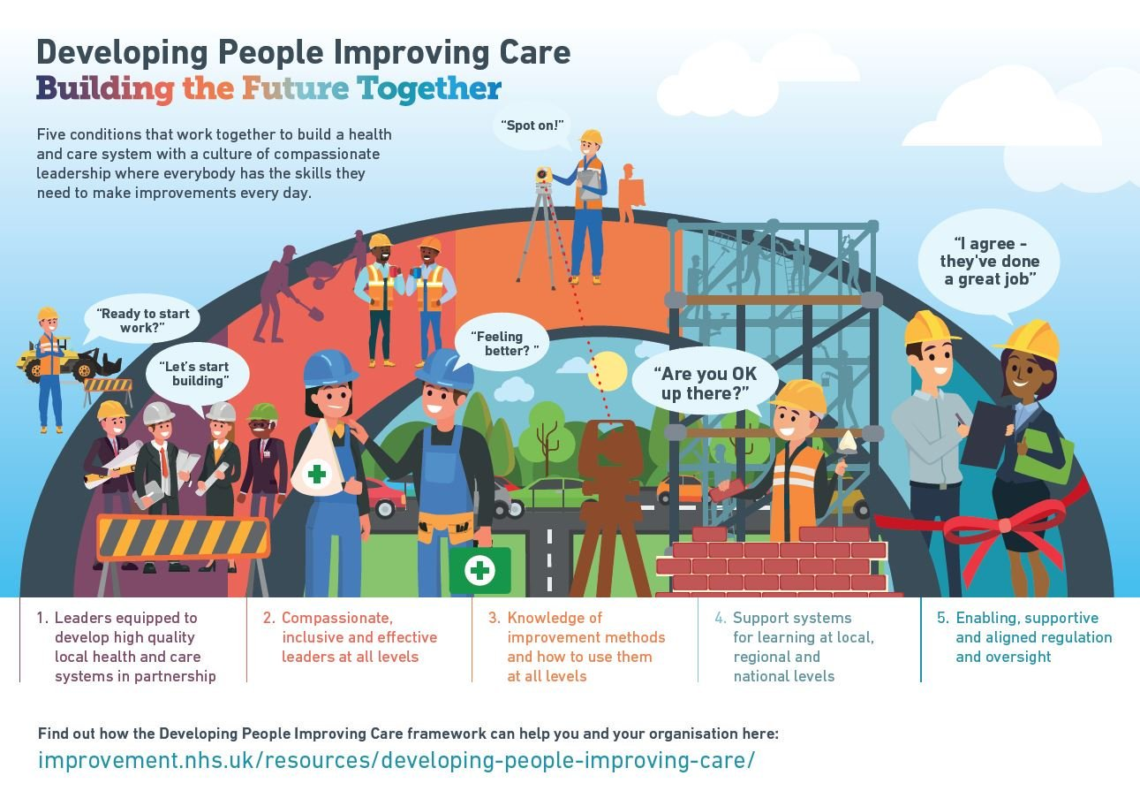

In the context of talent management, it specifically highlights a need to fill current senior vacancies and future leadership pipelines with the right numbers of diverse, appropriately developed people. To view the full framework and for further information, visit: Developing People: Improving Care

Well Led Framework

The well-led framework for leadership and governance was updated in 2017 and applies to all NHS and Foundation Trusts. It provides strengthened content on leadership, culture, system-working and quality improvement. New key lines of enquiry (KLOEs) make specific links to talent management activities in both organisational and system contexts.

Senior leaders will be expected to evidence the following:

- Their organisation takes a strategic approach to developing leadership and managing talent to ensure there are enough appropriately skilled, diverse and system-focused leaders to deliver high quality, effective, continuously improving compassionate care.
- A leadership strategy and succession plan are in place and regularly reviewed, based on quantitative and qualitative data. They should cover clinical and managerial leadership positions at board level and key roles below board level (such as clinical, operational and finance leads).
- They make use of relevant indicators in relation to the people or the human resources strategy, e.g. safe staffing, workforce capacity and capability to deliver the future strategy, performance appraisal, training and development, and leadership.
- That the organisation responds with flexibility and agility to the changes in the local health economy and takes part in pooled activities which may include local area talent management planning and leadership development.

The KLOEs linked to talent management are not exhaustive.  Organisations are being encouraged to scrutinise their current positions, and agree and evidence their intended actions.  Local partners are also encouraged to use this framework in a system context and emphasis has been placed in the guidance on proactive partnership working in talent management.  To view the full framework and for further information, visit: Well Led Guidance - NHSI | 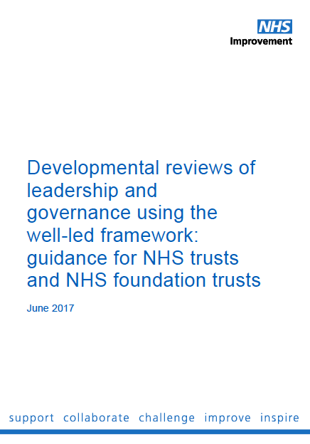
The NHS Long Term Plan

Leadership and talent management also features in the NHS Long-Term Plan, published in X. It sets out three key priorities for sustained and concerted action in relation to workforce as follows:

- ensure there are enough people, with the right skills and experience, so that staff have the time they need to care for patients well;
- ensure people have rewarding jobs, work in a positive culture, with opportunities to develop their skills and use state of the art equipment, and have support to manage the complex and often stressful nature of delivering healthcare;
- strengthen and support good, compassionate and diverse leadership at all levels – managerial and clinical – to meet the complex practical, financial and cultural challenges a successful workforce plan and Long-Term Plan will demand.

More specifically, it sets out intentions to do more to nurture the next generation of leaders by more systematically identifying, developing and supporting those with the capability and ambition to reach the most senior levels of the service. The national workforce group will look at options for improving NHS leadership pipelines. Building on the recent Kerr and Kark reviews, it will include:

- a systematic regional and local approach for identifying, assessing, developing, deploying and supporting talent, to be in place from early 2019;
- proposals to ensure that more senior clinicians take on executive leadership roles building on the recent Faculty of Medical Leadership and Management report on clinical leadership;
- expansion of the NHS graduate management training scheme, and support for graduates from the scheme, while also identifying high-potential clinicians and others to receive career support to enable progression to the most senior levels of the service;
- a consideration of the potential benefits and operation of a professional registration scheme for senior NHS leaders, similar to those used in other sectors of the economy and amongst other NHS professionals, which would recognise the role of NHS management and help the NHS attract and retain the best people for the most challenging jobs;
- measures to support transitions from other sectors into senior leadership positions in the NHS.

To view the full plan and for further information, visit: NHS Long Term Plan - Workforce

