
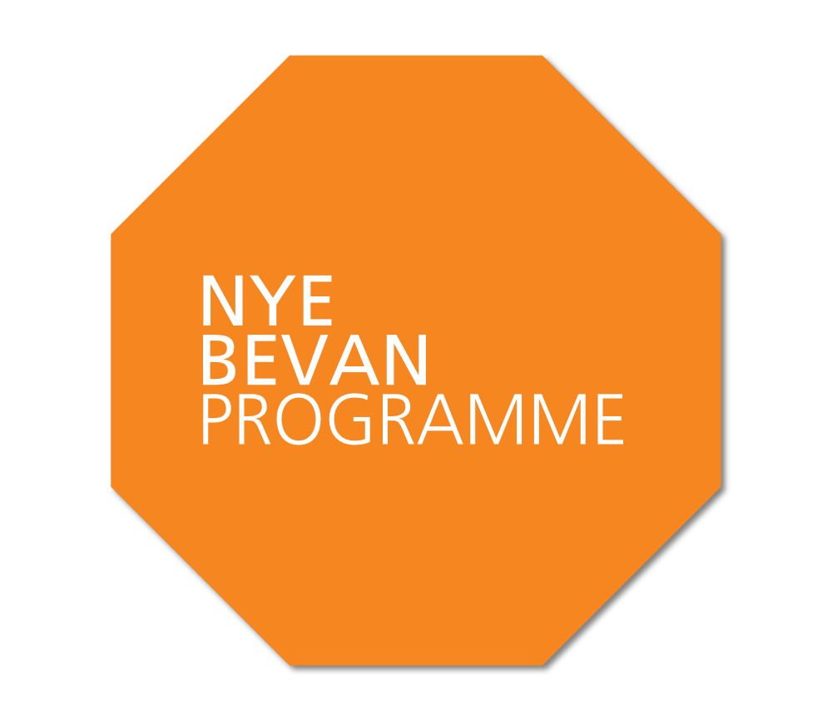

Nye Bevan
Terms and conditions

Nye Bevan Programme fees, terms and conditions (non-bursary)
for 2015/16

Applications for the Programme require the support of both the applicant’s line manager and their employing organisation.

By their signature on this form the applicant, the applicant’s line manager and the authorised signatory of the employing organisation confirm that they have read and are agreeing to the terms and conditions of this document.

The nature of the organisation that employs the applicant determines the fees payable for the Programme.

All organisations not providing NHS funded care(“Non-NHS Organisations”) | £19,500
All organisations providing NHS funded care (“NHS Organisations”) | £13,500

There is a small bursary scheme for which a separate application is required, see www.leadershipacademy.nhs.uk for further details.

Please complete the information requested and sign in the places provided.

Name of organisation employing the applicant:
Corresponding fee payable:
Required study time: 10 hours average a week
Required face-to-face study days: 18 days in total over 1 calendar year
Programme contains residential elements: Yes, 4 residentials in
Leeds or elsewhere

Applicant name:
Signature:

Date:
Line Manager name:
Signature:

Date:

Name of authorised signatory for the NHS Organisation/Non-NHS
Organisation:
Signature:

Date:
Finance contact name:
Invoicing address:

Invoicing contact number:
Invoicing contact email:

1. By their signature above the authorised signatory for the NHS Organisation/ Non-NHS Organisation confirms:

1.1 The applicable Programme fee entered above will be due payable upon acceptance by the applicant of a place on the Programme. The invoice will be paid in full within 30 days of issue by the Academy.

1.2 Programme fees cover all Programme costs and accommodation where indicated above as being required. Travel and subsistence other than lunches during the learning days is not covered and the organisations’ own expenses policy will apply.

2. In addition the authorised signatory for the NHS Organisation confirms:

2.1 If, having accepted a place, the applicant either fails to start or fails to complete the Programme for any reason whatsoever (other than for a reason that the Academy (in its absolute discretion) determines is an extenuating circumstance), the NHS Organisation will pay the Academy the sum of £6,000 (being the difference between £19,500 and £13,500) against the Academy’s invoice therefor as agreed recompense to the Academy for subsidising the applicant’s place on the Programme.

3. By their signature above the Line Manager confirms:
3.1 I fully support the applicant to take part in the Programme and agree to make the necessary work-place arrangements for the applicant to attend all of the face-to-face elements as detailed above.
3.2 The amount of paid or unpaid study leave the applicant receives in addition to complete the required study time detailed above will be determined by the relevant policy of or by the management of the NHS Organisation or Non NHS Organisation.

4. By their signature above the applicant confirms that:
4.1 If I am from outside of the EU and working in England with a visa, my UK Border Agency clearance covers study as well as work;
  - I will not share my access to the learning environment, or download, plagiarise or distribute any of the learning materials to anyone;
  - I will complete all of the face-to-face study days (as detailed above) and all of the learning activity associated with the Programme, including all of the assignments regardless of the amount of study leave I am granted. I understand that all the elements of the Programme are compulsory and attendance is part of the assessment, pass mark and Academy accreditation;
  - I understand that these programmes are designed around practical learning in the workplace – the most important environment for me to learn and develop as a leader – and that I will not be able to complete the programme without application in my workplace;
  - I will ensure that I have enough access to the on-line learning environment to complete the significant amount of online learning required. I will make the NHS Leadership Academy aware of any accessibility issues I have in this regard so that appropriate support can be found before the Programme starts;
  - I understand that, if I am employed by an NHS Organisation and I move jobs during the Programme that:
  - this does not constitute extenuating circumstance for withdrawal from the Programme; and
  - I will make my new employer and line manager aware before I accept the job offer that I am committed to complete the Programme and will require their support to do so;
  - I will use my best endeavours to have a new version of this document completed by myself, my new line manager and my new employer’s authorised signatory which both acknowledges the payment already made and accepts liability to pay the Academy £6,000 if I fail to complete the Programme;

4.7 I agree to my personal data (whether supplied by me, collected by the Academy via the application process and from time to time throughout the delivery of the Programme) being shared by the Academy with its contracted service providers (their global organisation(s) and subcontractors) and the Academy and/or its contracted service providers (their global organisation and subcontractors), may share or disclose my personal data to a third party for a specific purpose, for example where the Academy needs to provide a caterer with meal preference information. In addition I agree that my personal data may be routed, stored, or transferred internationally both inside and outside the EU on the understanding that the Academy has sought assurance from its contracted service providers (their global organisation and subcontractors) that they have policies in place to ensure an equivalent level of protection is in place as is provided by the Academy; and
4.8 I understand that there may be audio recording, filming and / or photography of me, taken whilst on the Programme. I agree that the Academy may use pictures (incl photographs), film, audio and video recordings of me made during the Programme may be used to showcase the Programme including promoting it in the NHS, to Central Government, and to the general public via the Academy’s website or other media.

