**Connecting Staff to the Frontline**

**By Liz Playford, Experience of Care and Participation Team and Rob Green, Research & Evaluation Team**

We would like to say a big thank you to the Leadership Academy for allowing staff to spend some time volunteering as part of the Connecting Staff to the Frontline scheme. We decided that we would like to spend one day volunteering at the national Academy’s chosen charity for this year, [St George’s Crypt in Leeds.](https://www.google.com/search?q=st+george%27s+crypt&rlz=1C1GCEA_enGB819GB820&oq=st+george%27s+crypt&aqs=chrome..69i57.4976j0j8&sourceid=chrome&ie=UTF-8)

**A bit of a breakdown of our day:**

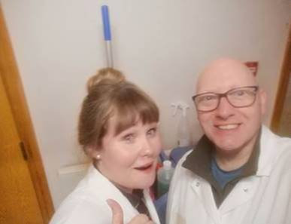

**10am –** Arrival and introduction to staff and a guided tour around the Crypt (including some interesting information on its history - neither of us had any idea that the Crypt had been going since 1930 and the legend that was Don Robins!)

**11am –** We put on our overalls and got to work! We were informed that we would be serving the 3 course lunches in the kitchen. We started with some kitchen prep and then begun our shift serving the food, which consisted of: an asparagus soup for starters (courtesy of Marks and Spencer donating supplies the day before), chicken casserole with potatoes for a main meal (from another supermarket chain) and a variety of puddings including cheesecake and a chocolate roll. From 11am, the residents who had stayed the night before came into the kitchen and were given a meal and then it was steady away until 12pm exactly, whereby the floodgates opened and around 150 people entered the Crypt for their daily meal.

This was a really rewarding experience – to meet so many people, provide a welcome meal and feel as though in some small way we were being helpful. It really put things in perspective for both of us and we were reflecting on this throughout the rest of the day.

**1pm –** People finished their meals and begun to leave the Crypt, so we began clearing away both front of house and in the kitchen, in preparation for the next meal. Once we finished clearing up in the kitchen we were given mops and a sweeping brush and begun our next task and set to work.

**2.30pm –** We came to the end of our shift and said our goodbyes – with a takeaway of how lucky and privileged we really are and with a sense of wanting to go back and help the Crypt out again.

If you would like to help St George’s Crypt, they would appreciate a supply of individually packed / wrapped sweets for their next tombola, in Bramham Leeds on the 16June. If anybody would like to contribute with some sweets, please give to either Liz or Rob who will take these items up to the Crypt.

As always, there are the collection boxes for any donations for the Crypt in the staff kitchen / by the coffee station in the ground floor office.

Thank you for reading

Liz and Rob

[Rob.green@leadershipacademy.nhs.uk](mailto:Rob.green@leadershipacademy.nhs.uk)

[Liz.playford@leadershipacademy.nhs.uk](mailto:Liz.playford@leadershipacademy.nhs.uk)