**Connecting to front line**

**By Christine Hodgson, team administrator, Experience of Care and Participation Team, NHS Leadership Academy**

As part of National Experience of Care Week, I volunteered with St Gemma’s Hospice in Leeds. St Gemma’s Hospice was established on 12 April 1978 and provides care and support to patients and families coming to the end of their life. I supported the opening of their new charity shop in The Merrion Centre, Leeds.

I helped to price up clothing as well as steam iron them and put them on the various racks for sale. Although the shop had only just opened, it was very busy and I enjoyed talking to the various customers who passed through the doors. Many of them had experienced dealings with St Gemma’s, and were especially interested when I talked about my role in the Leadership Academy engaging with the patients and all agreed this was a wonderful thing to do. One of the most interesting things I learned was the tale about the wedding dress and thought I would share this with you.

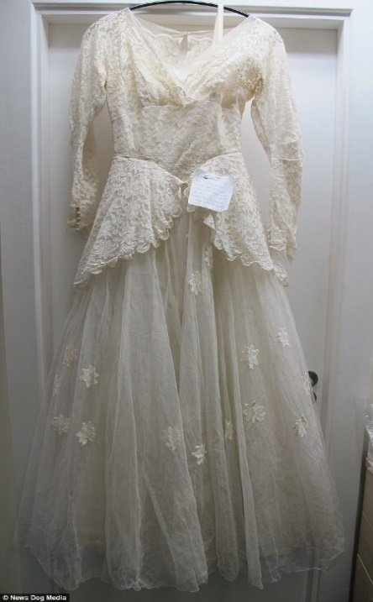A pensioner who sparked a media storm when he donated his late wife's wedding dress to charity said he feels 'proud and elated' that it has sold for nearly £3,000. St Gemma's Hospice launched a worldwide search to find 'the kind gentleman' after he handed the vintage gown into their charity shop in Garforth, Leeds, with a heart-rending note attached a fortnight ago. The note read: 'I wish any lady who takes this dress to have a life with her loved one, 56 years like I did, happy years. I was a lucky man to marry a lady like mine.' The charity shared pictures of the dress and note on their social media websites with an appeal to find the donator to thank him personally. His story touched the hearts of many around the world, leading to enquiries to buy the dress from Australia, Hong Kong and the U.S as well as all over the UK. As a result, the charity decided to put the dress up for auction on eBay to allow more people to have the chance to buy it and are delighted it eventually sold for £2,910. The gentleman was eventually located but wished to remain anonymous.

