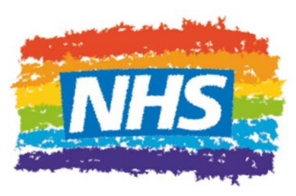

NHS Rainbow Badges
Please do not complete this form on behalf of other people. This form must be completed by the person requesting the badge so that they fully understand what it means.
Name:
Job title:
Email:
Influencer Group:
Pledge (we do encourage something with a tangible action):
I pledge that…

I confirm that:
- I understand wearing a badge gives a positive message of inclusion and means I have a responsibility to be someone who is a friendly ear for LGBT+ people
- I have read the information on this page and explored the support materials
- I understand what to do if I think a situation requires escalation
- By choosing to wear this badge, you are sending a message that “you can talk to me” about issues of gender and sexuality. You aren’t expected to solve all their issues and concerns, but you are a friendly ear and will know how to signpost to support available.
We’d like to collect information about what motivates people to wear a badge. We may use this quote anonymously to promote the badges to others (we will keep this comment anonymous unless you are happy to be named).
Please tell us in a few words. I would like to wear a badge because...

