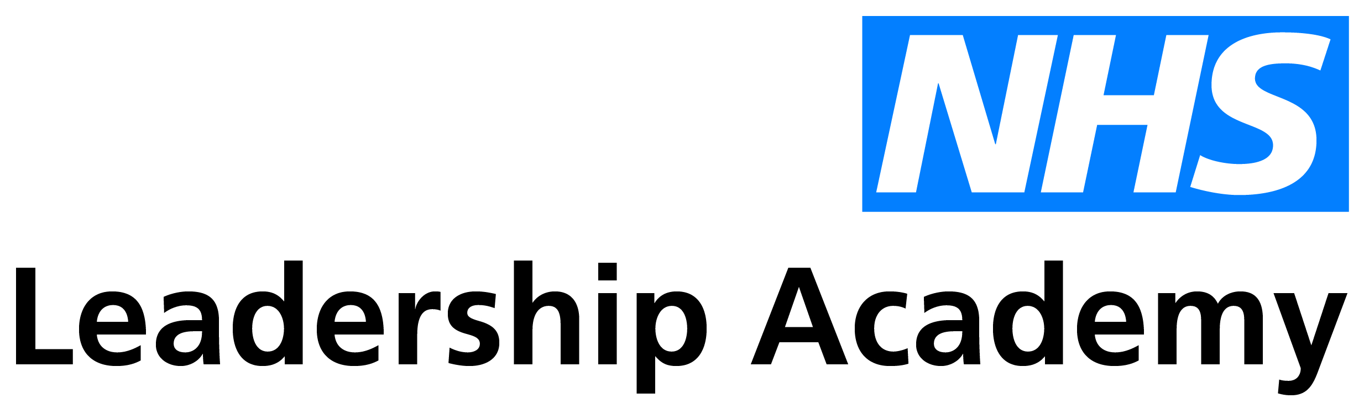

“They called me ‘monkey’ and ‘baboon’. Many times I went into the toilets and I cried and said, ‘Father, I’m just asking you to give me courage’. I cried and I prayed.” Merlyn Amelder Williams
Naomi Brennan, marketing officer at the national Leadership Academy tells us about her nana, Merlyn Amelder Williams and her contribution to the NHS as part of the Windrush generation.
The Windrush generation is the name given to those that arrived in the UK between 1948 and 1971 from Caribbean countries. They are named after the ship 'the Empire Windrush' which arrived at Tilbury Docks in Essex in 1948. At this time Britain was just starting to recover from World War II, thousands of buildings had been bombed, houses destroyed, and it all needed to be rebuilt. Not only that but for nurses, midwives and other healthcare staff, there was an active invitation from the British government to come to England and work in the newly formed National Health Service.
Thousands travelled from their homes overseas, answering Britain’s call and excited about the opportunities on offer while enabling them to support their families back home. Upon arrival most were given jobs which involved menial tasks that denied them the job opportunities enjoyed by white colleagues. Many had to endure racist abuse, but they persisted for their families and communities. All four of my grandparents are part of this courageous story, coming from Jamaica, St. Kitts, Cuba and Monserrat.
In the spring of 1961, my Nana arrived in Leeds. Nana worked in the kitchens of Leeds General Infirmary for 9 years where she faced appalling racism of which she endured for the sake of her family. She then went onto work in social services for the next 24 years as a trades union shop steward. Later, Nana trained to become a chef and after retirement, she opened a cafe in Chapeltown called the Dunns River cafe, named after one of Jamaica’s most popular tourist attractions. Nana was the best cook; I remember visiting the shop often with my little sister after school.
A new exhibition celebrating the lives of Jamaicans who settled in Leeds after World War II has opened at Leeds library. It's called "Eulogy" and will run until 1 September. It documents the lives of West Indians who travelled to the UK to fill labour shortages in the NHS and many other industries.
I'd recommend going to learn more about the inspiring individuals that made a life in Leeds. There, you will also see Merlyn Amelder Williams, my Nana.

